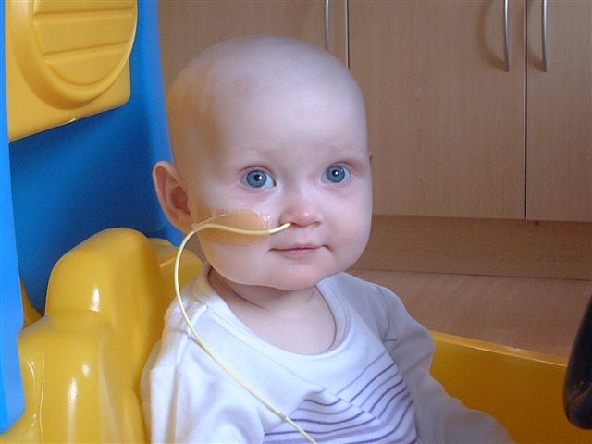

Dear Sir/Madam

No doubt this is not the first time you have seen this little girls picture, or been asked to make a donation to help raise the massive £450,000 needed to save her life. I’m not asking you to make a donation but offering you the opportunity to help Save Our Sara, at the same time promoting your company, raising your profile or just having a great night out.

This family have already lost Sara’s big sister, please help us save this precious little girl.

Odeon Dunfermline in conjunction with Twentieth Century Fox are pleased announce the UK Premiere of ALIEN VS PREDATOR. This celebrity gala event will take place on Thursday 7th October. Doors open at 7.00pm commencing with an auction of film memorabilia and other donated items. After the auction the film will commence its very first run in the UK

There are three ways in which you can get involved:

We are offering a chance to advertise in the Premiere Programme.
600 programmes are being produced and will be sold on the night; the costs to advertise in the programme are as follows:
Full page 19x19 £300
Half Page 19x8 £180
Quarter Page 8x8 £100
You will receive your own copy of the programme and advertisers can place whatever they feel is appropriate in the programme i.e. a good luck message from all at: @@@ or a generic advert for their business i.e. Alien VS Predator toys available at @@@. All of the proceeds from the programme will go to the SOS fund.

Buy a block of tickets
There are only 300 tickets available from Monday 6th September. These will be on a first come first served basis and as such are very limited. The cost of a single ticket is £20.00 although there is no limit on how much you can pay for the ticket. An order form is attached. The film has been given a 15 certificate by the BBFC and therefore only persons of that age and over will be allowed admittance.

Donate a gift for auction or prize draw
We have already been offered some wonderful prizes, but need lots more. A gift of any size that we can auction or raffle would be welcome. Everyone donating a gift will receive an acknowledgment in the brochure.

Sara and her family’s story is one of the saddest and most tragic I have ever heard. Because of the tenacity and dedication of the people organising the appeal a lot of money has been raised, but a lot more is needed. The generosity of the people of Fife, and further a field, has been absolutely incredible and the target is now in sight. Please support this event, we propose to raise in the region of £20,000 and every single penny will go to sending Sara to America for her life saving treatment.

Thank you for taking the time to read this letter and I hope to here from you soon.

Yours sincerely

For more information or details of how you can help please do not hesitate to phone/email or write to:

Colin Rawling

Twentieth Century Fox
Colin.rawling@fox.com
07944 690308

Gifts or prizes should be addressed to:
Colin Rawling (SOS FUND)
27 Fod Street
Dunfermline
KY11 8EJ
(Cheques made payable to Save Our Sara Fund and auction items must be sent to this address)

…………………………………………………………………………………………………………………

Save Our Sara Charity UK Premiere

ALIEN vs PREDATOR

I wish to purchase______tickets and enclose a cheque

for £__________ (Minimum donation £20 per Ticket)

Name _____________________
Address _____________________
_____________________

Postcode _____________________
Telephone _____________________

If you would like to purchase tickets using a debit or credit card please contact the Odeon, Dunfermline by calling 01383 626491

